RETROSPECTIVE

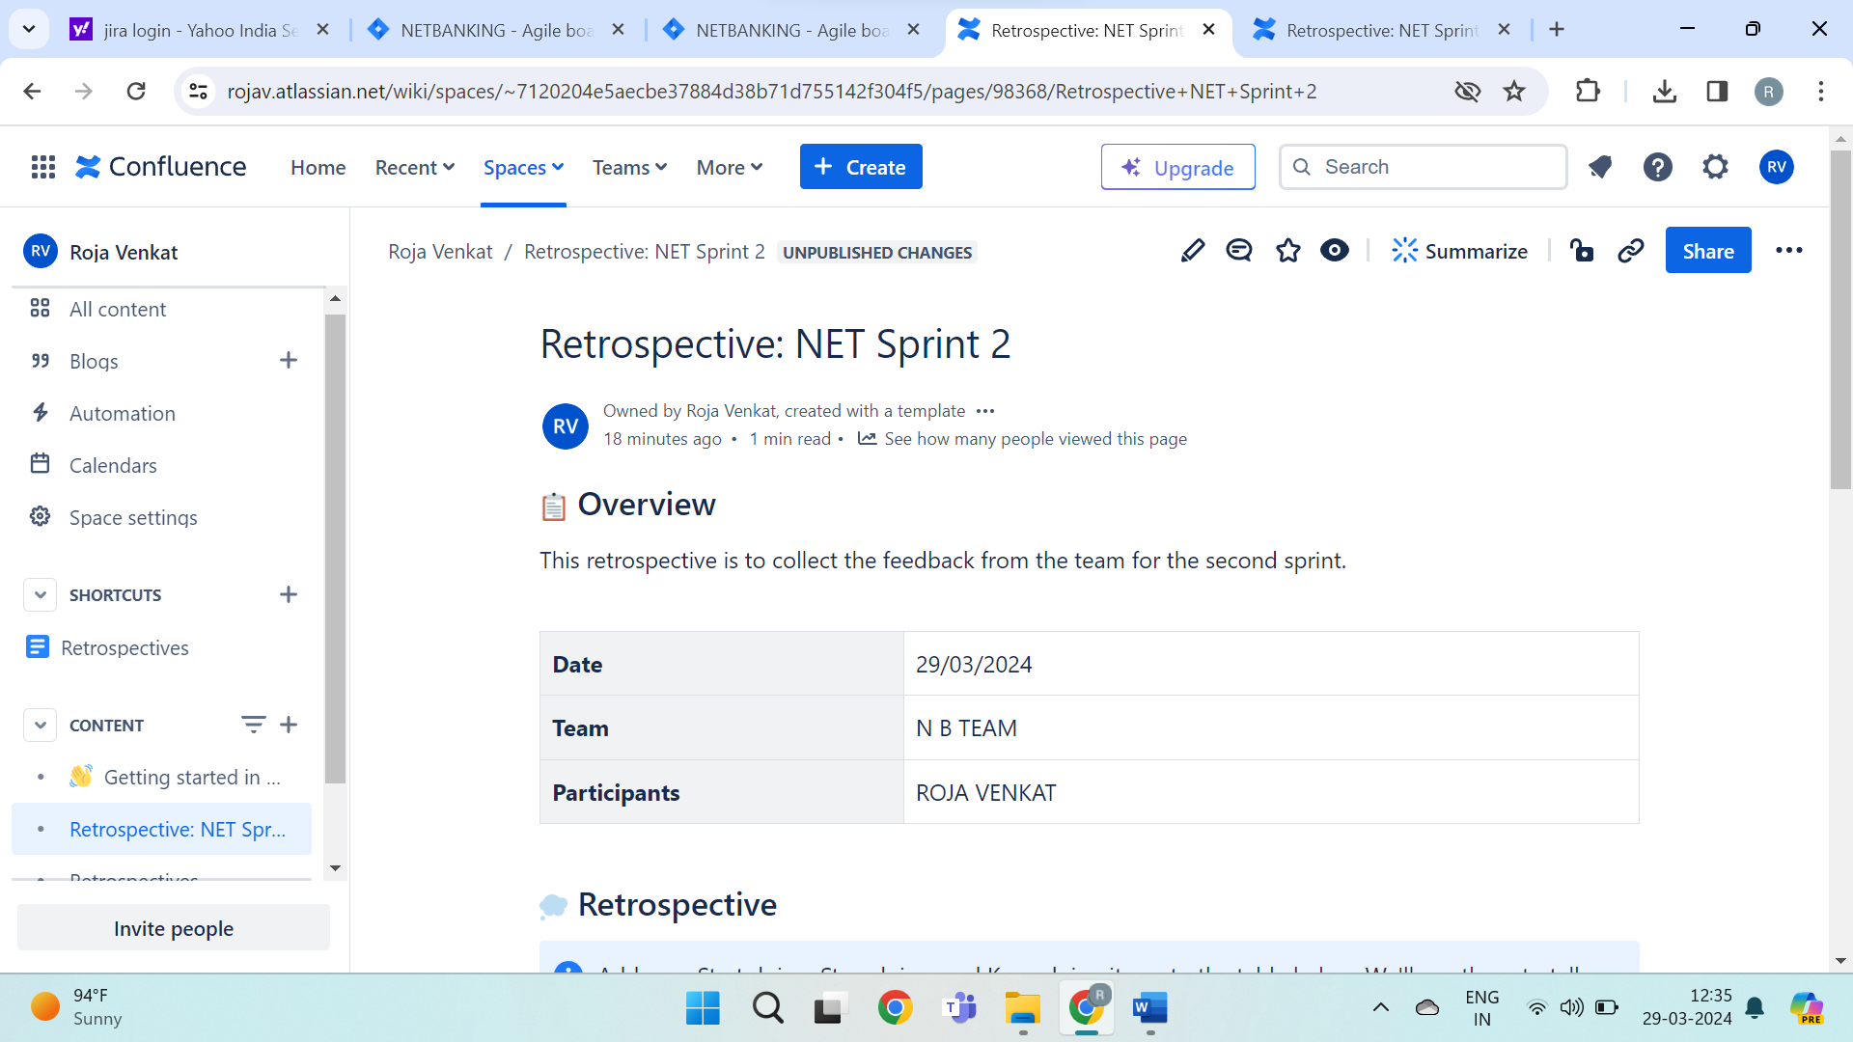

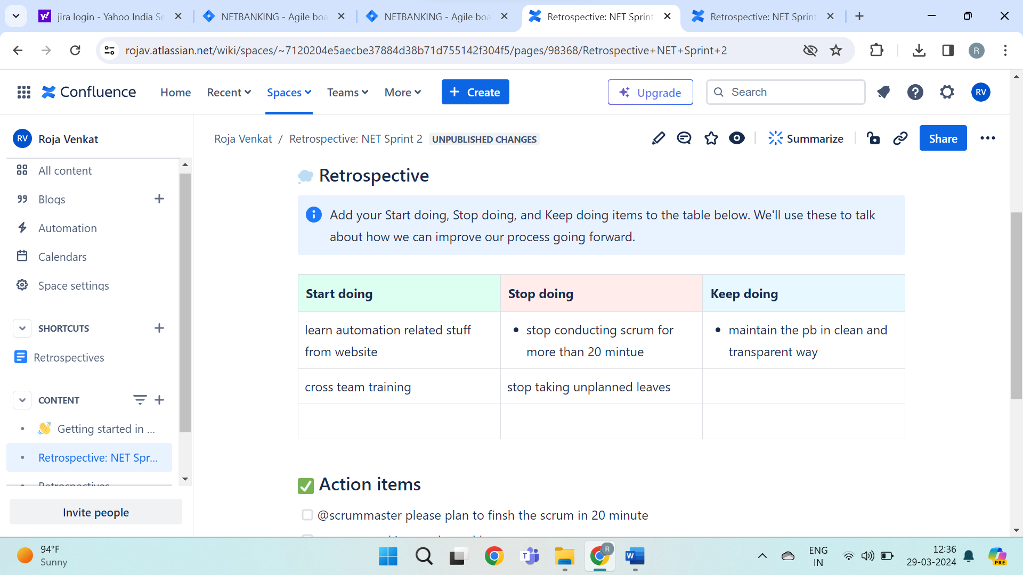

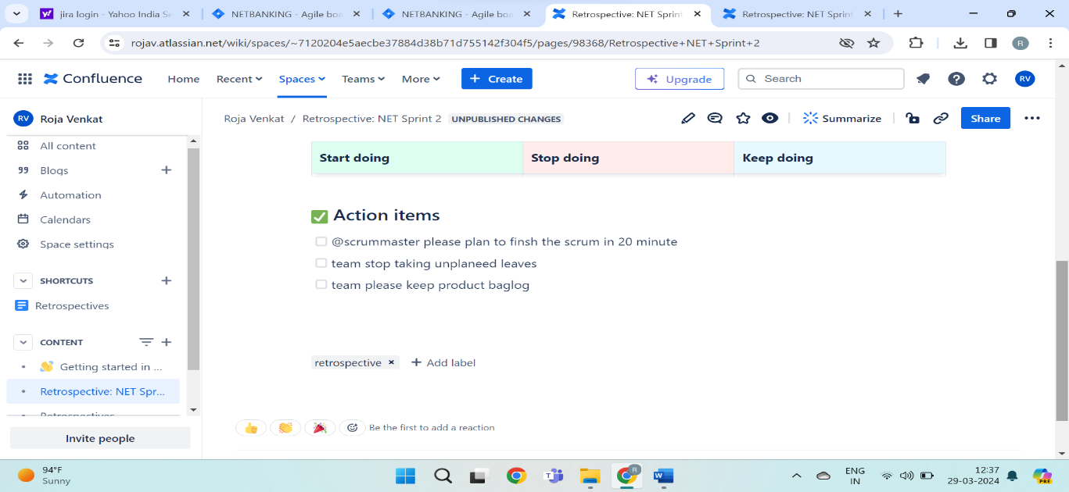  
SPRINT REPORT

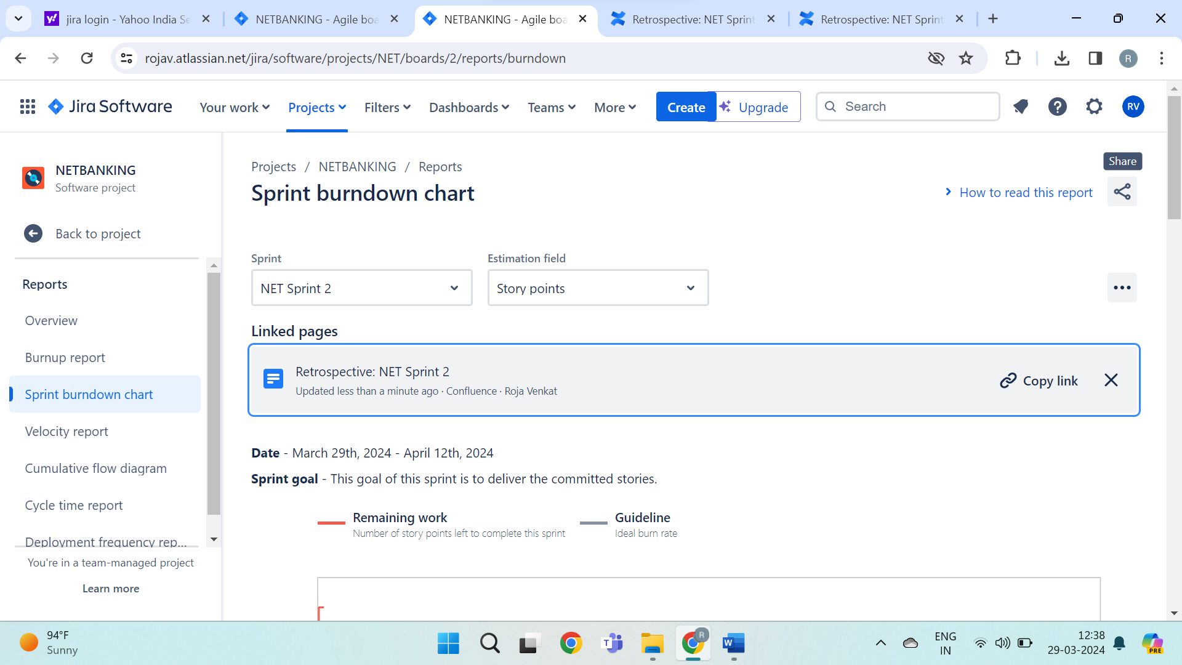

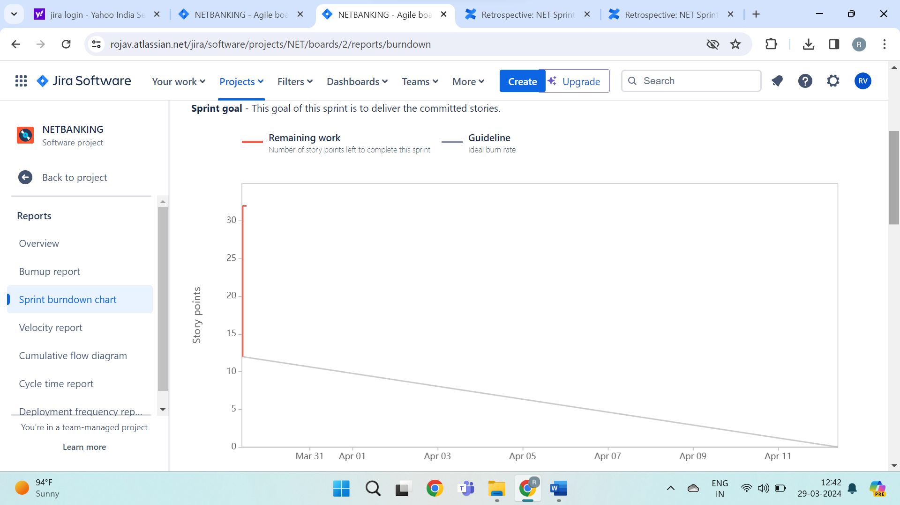

SCRUM MEETING

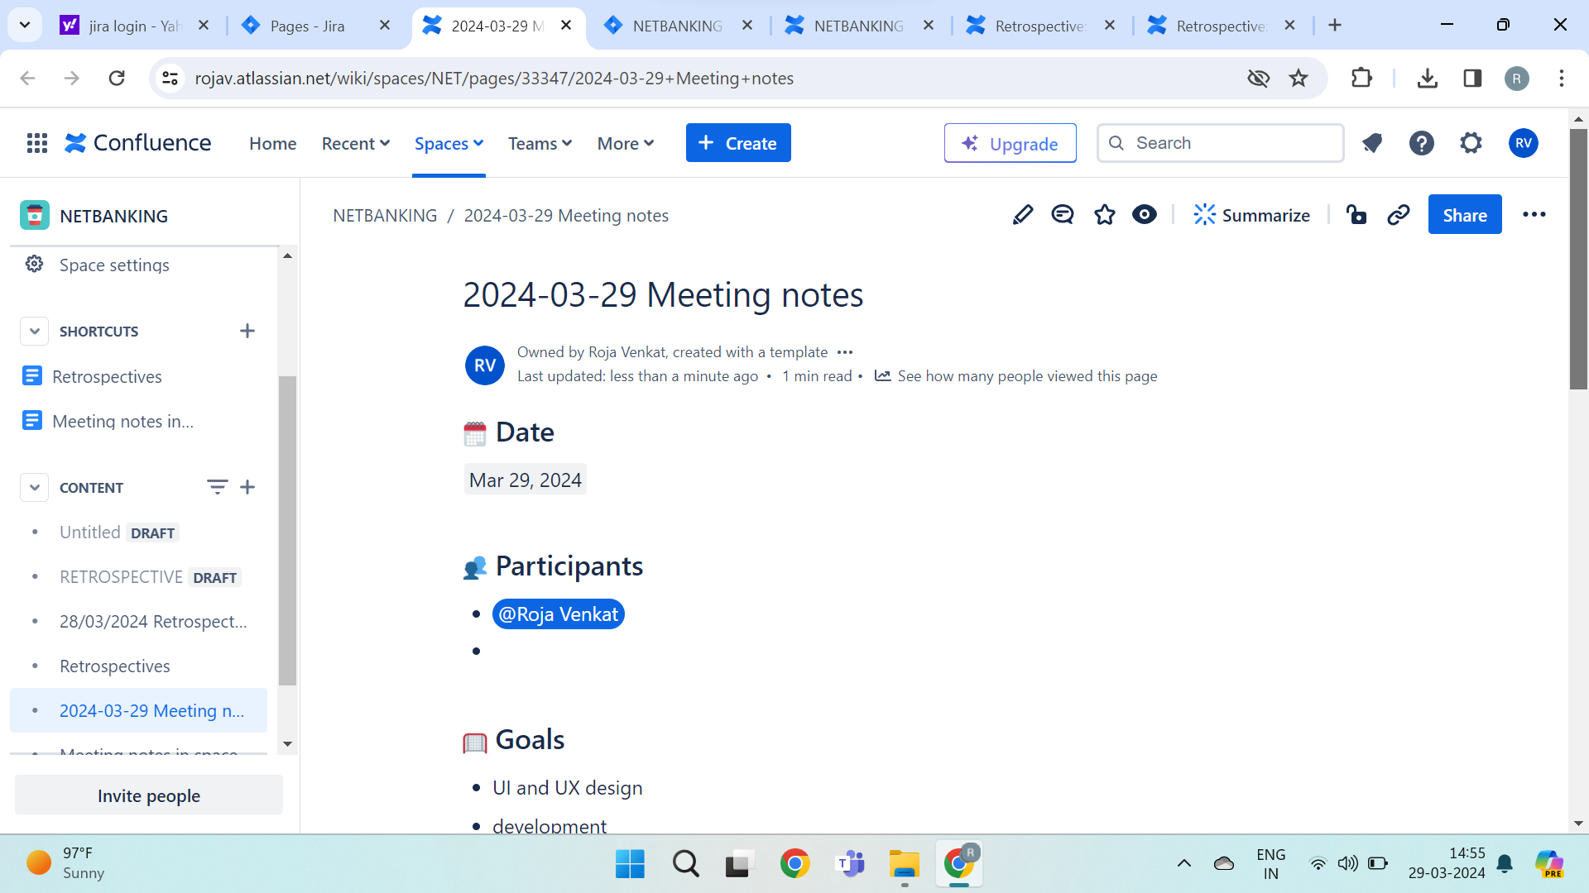

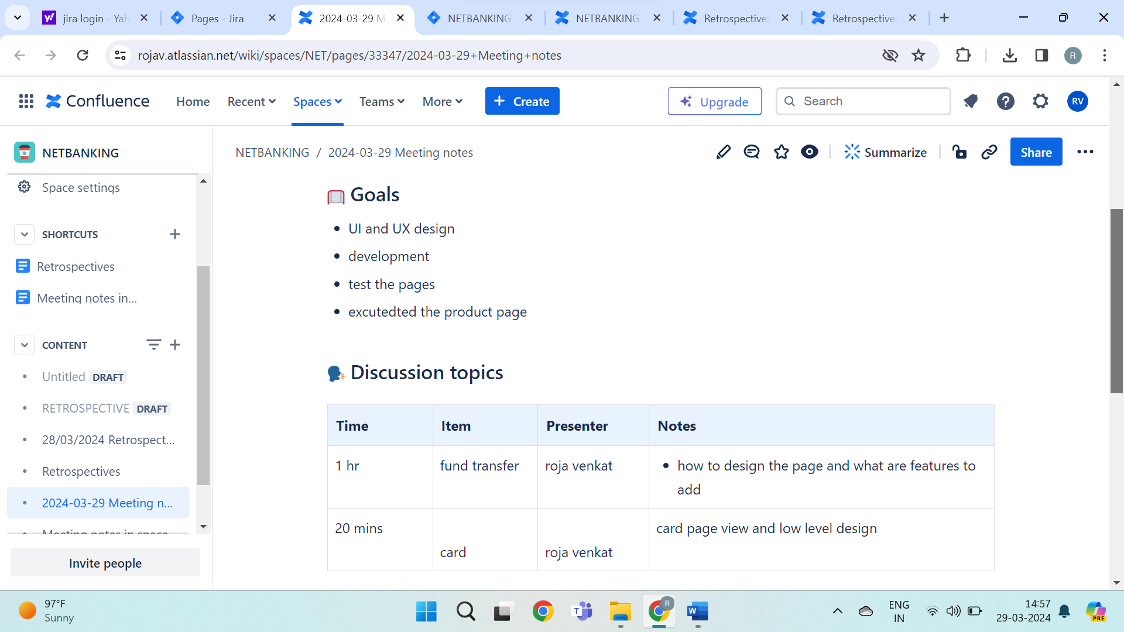

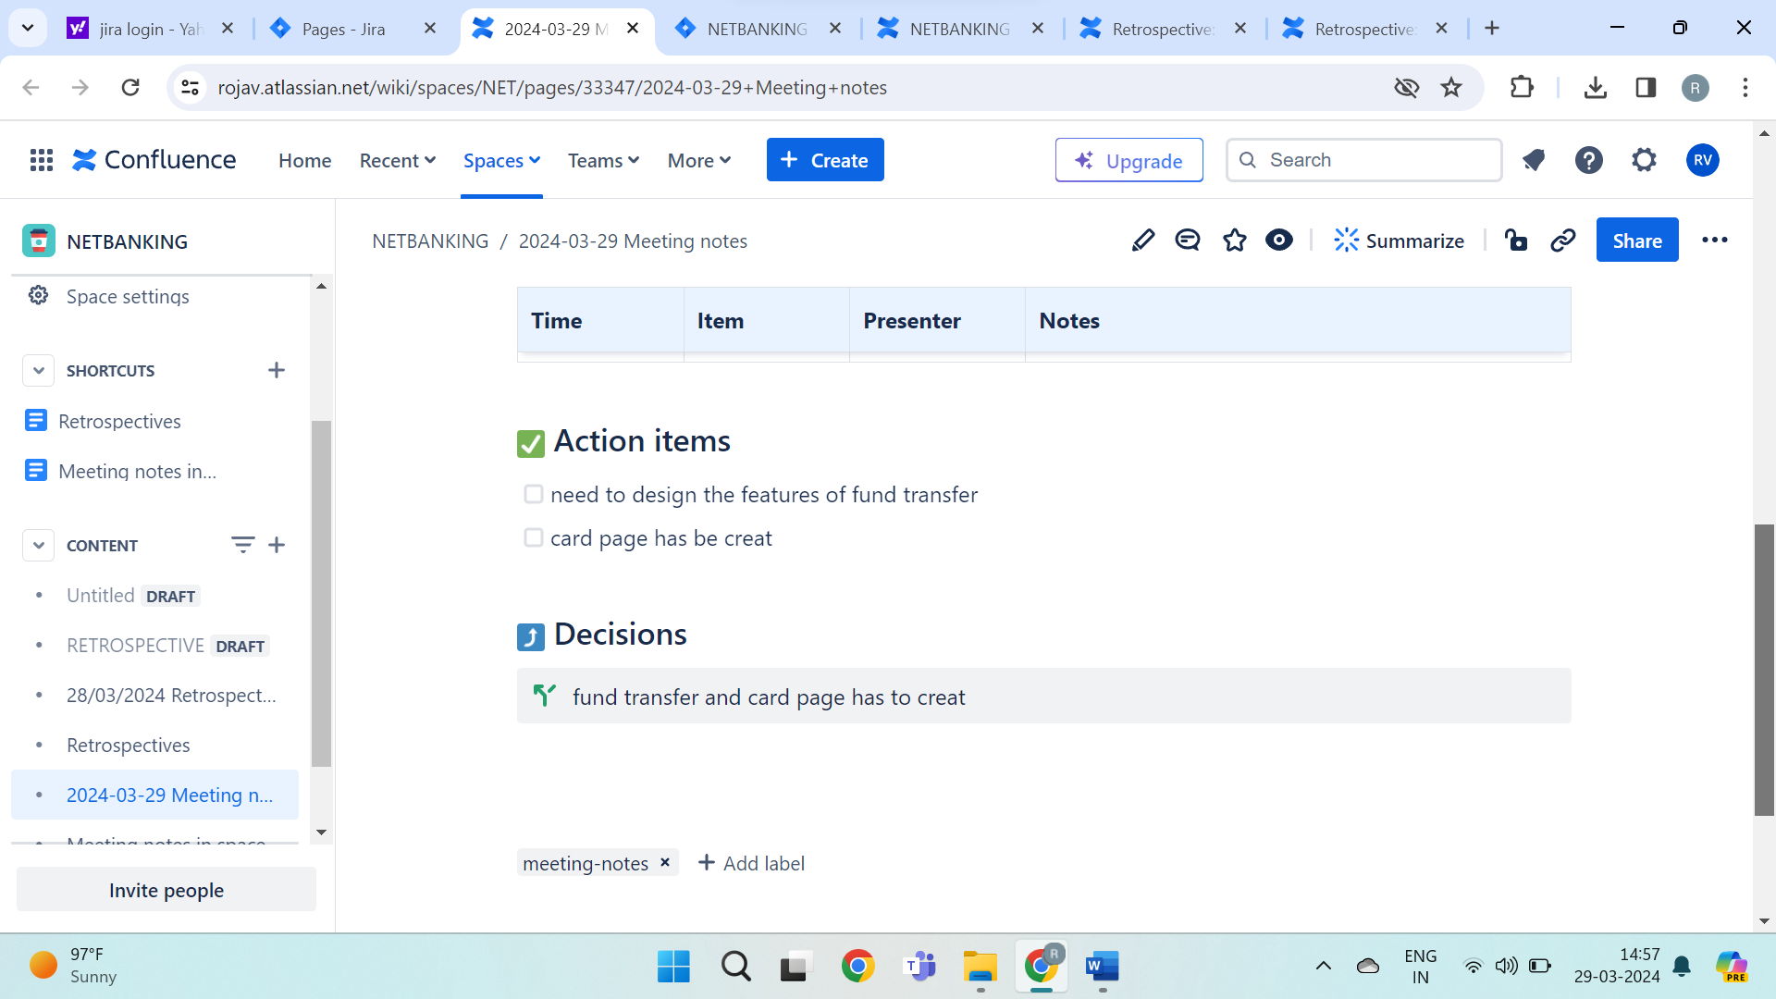

ROLES INOLVED IN SCRUM

PRODUCT OWNER

The PO is responsible for servicing and monitoring the product backlog, which is prioritized list of deliverables.

BUSINESS ANALYST

Assess how organisations are performing and help them improve their process and system.

MANAGERS

Create a new project role called sprint, assign the manage sprints permission to the sprint manager project role.

TECH ARCHITECT DEVELOPMENT AND TESTING TEAM

Technical architects act as vital bridges between business needs and technological solutions, overseeing the design and implementation of IT system.

Develop and maintain automation workflowa, develop plugins to extent jira capabilities, build dashboards for jira connect add, configure customer fileds.

Testing is to tract ,organize and prioritize issues, bugs, features and task related to software.

OPERATIONS

The templates in jira work management allow your operations team to work easily and efficiently in one place.